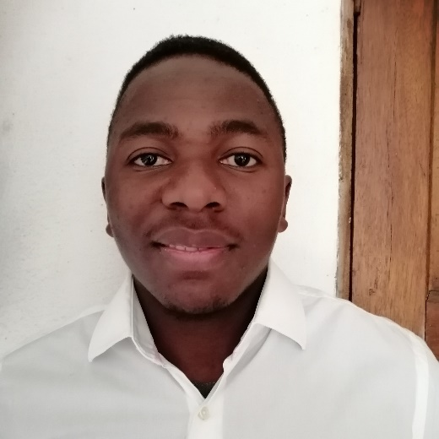­­­­­HH

[linkedin.com/in/ashleigh-manyanye-060222215/](https://www.linkedin.com/in/ashleigh-manyanye-060222215/)

Gardening

 Cycling

0645 472 517 / 0631 451 765

⌛



27 439, Phaliso Street, Strand, Cape Town, 7139

https://ashleigh-tesla.github.io/myPortfolio/



**Frontend Web Development**

**2020 – 2021**

I obtained my certificate in HTML, CSS, JS, VUE.js, NODE.js, AJAX.js, Bootstrap, Web Design and Deployment.

**CODESPACE**

**Backend Web Development**

**2021 – 2022**

I developed projects in PHP and MySQL then I deployed them locally using phpMyAdmin.

**SAINT DOMINICS HIGH**

**Advanced Level**

**2017 – 2018**

I passed all 3 subjects, and they are Mathematics, Physics and Chemistry.

**SAINT FAITHS HIGH**

**Ordinary Level**

**2015 – 2016**

I passed all 10 subjects, and they include Mathematics, English and Science.

**INTERESTS**



ashleightesla@gmail.com



**CONTACT**

 CSS





  

   

   

**PROFILE**

**SKILLS**

I am an aspiring, enthusiastic Web Developer looking for an internship.

I wish to apply and execute all the skills that I obtained in software development.

**EDUCATION**

**ASHLEIGH MANYANYE**

**CURRICULUM VITAE**